Write-up for Transfer of Technology
Name of Technology: Microwave Chaff Cartridge (Non-Explosive)
Name of DRDO Lab /Estt: Defence Laboratory, Jodhpur

Description of the Technology:Chaff is one of the most widely used and effective expendable electronic countermeasure device. It is a form of volumetric radar clutter designed to interfere with and confuse the radar detection. It is dispensed into the atmosphere to deny radar acquisition, generate false targets, and to deny or disrupt radar tracking. The chaff cartridge contains millions of chaff fibers having dia 25 ± 4 micron and different lengths as chaff pay load to cover frequency band of interest.
DLJ has developed a new process for making of continuous fine fibers of Al in range of 25 ± 4 micron diameter by chemically processing commercially available 115 micron diameter Al wire. The fibers are further treated by slip coating process to make the surface smooth and slippery. The methodologies and techniques for cutting, packing and assembly of Chaff packs are also established. The indigenous material has functional properties in terms of chaff cloud blooming and dynamic RCS similar to imported chaff material. The external hardware components of the Chaff Cartridge like Cartridge container, piston, end-caps, cushion, etc. has been designed and developed by HEMRL, Pune with suitable Material of Construction (MOC) of each component. Thus the entire Chaff Cartridge for IAF application has been developed by DRDO.

Process details: The step wise process details are given below:
- Multiple Wire Winding:DLJ has create a setup for winding multiple wires from commercially availablesingle wire spools of115 micron, to form a single spool of multiple wires.
- Pilot Plant: These multiple wires of 115 micron are then passed through chemical etching bathsto reduce the size of these wires to 25 ± 4 micron.
- Post treatment: The surface finish of these fibers are further improved by a chemical slip coating treatment.
- Cutting & packing: Known weight of finished fibers are packed wrapped in Kraft paper to form chaff hanks. Chaff Cuts of different lengths are then prepared by cutting these chaff hanks using DLJ developed cutting mechanism.
- Assembly: These chaff cuts of different known lengths are filled inside the Cartridge container along with piston, end-caps, cushion, etc. which are designed and developed by HEMRL, Pune, in a predefined order to form the complete Chaff Cartridge.

Application Areas: As Electronic Countermeasure in Defence.

Certifications:
Airworthiness Certificate obtained from RCMA (AA). (Enclosed as Appendix A)
Airborne Trials with Jaguar Darin-II will commence in October 2017

Photographs
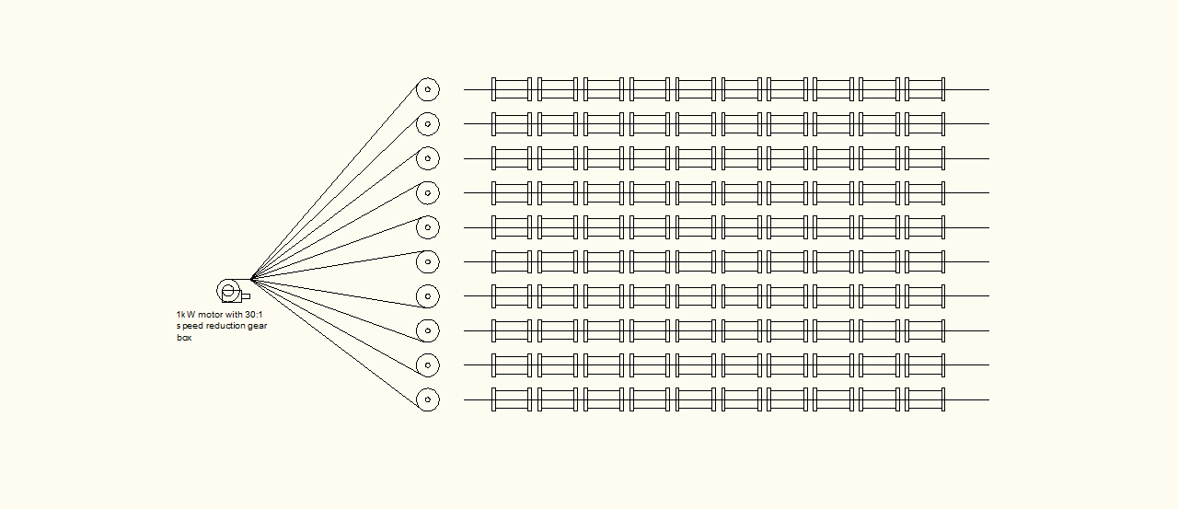
Fig. 1: Schematic diagram of multiple wire winding machine

Fume hood with 1HPradial blower, capacity 400cfm@6-7 inch water column pressure.
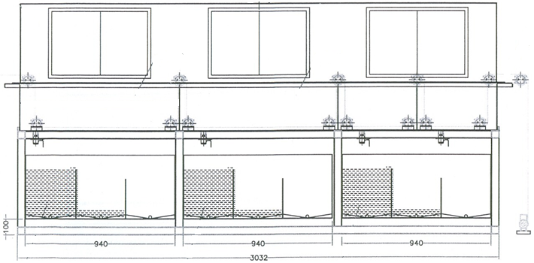
Etching Solution, temp. 50-55⁰C
Al. wire (4000 Nos.), dia 115 µm
VFD controlled 3 phase motor with planetary gear box to obtain linear fibre speed of 20-40cm/min.
Washing chamber, room temperature
Collection chamber
Continuous Al fibre of Dia 28-33 µm

Fig. 2 : Schematic diagram of continuous Aluminium fibre making machine

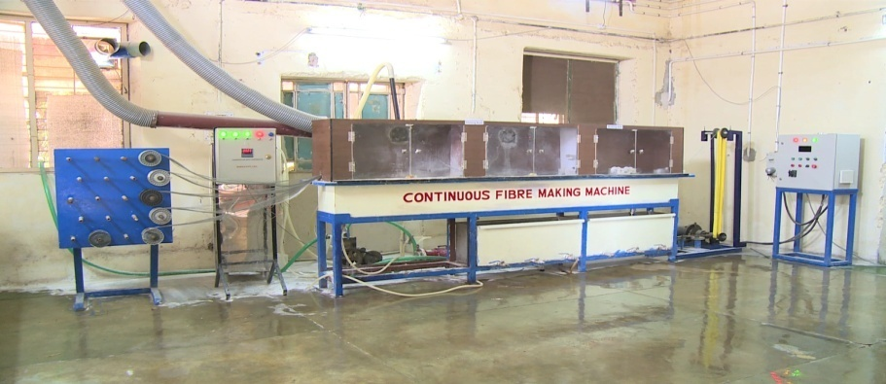
Fig. 3: Actual photograph of continuous aluminium fibre making machine

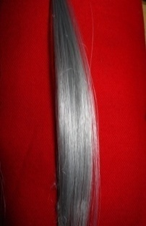
Fig. 4: Finished Fibers

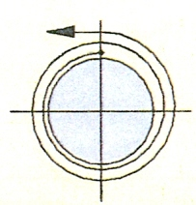

Fig. 5: Chaff Pack wrap (two turns of glazed Kraft paper)

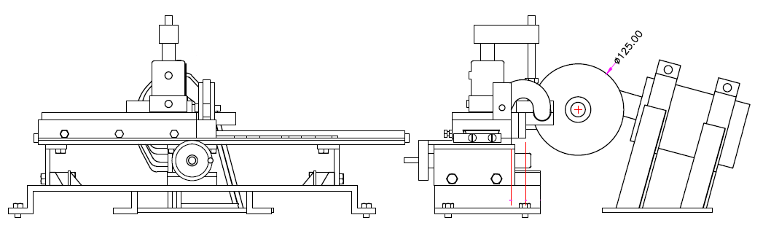
Fig. 6: Schematic diagram of chaff cutting machine

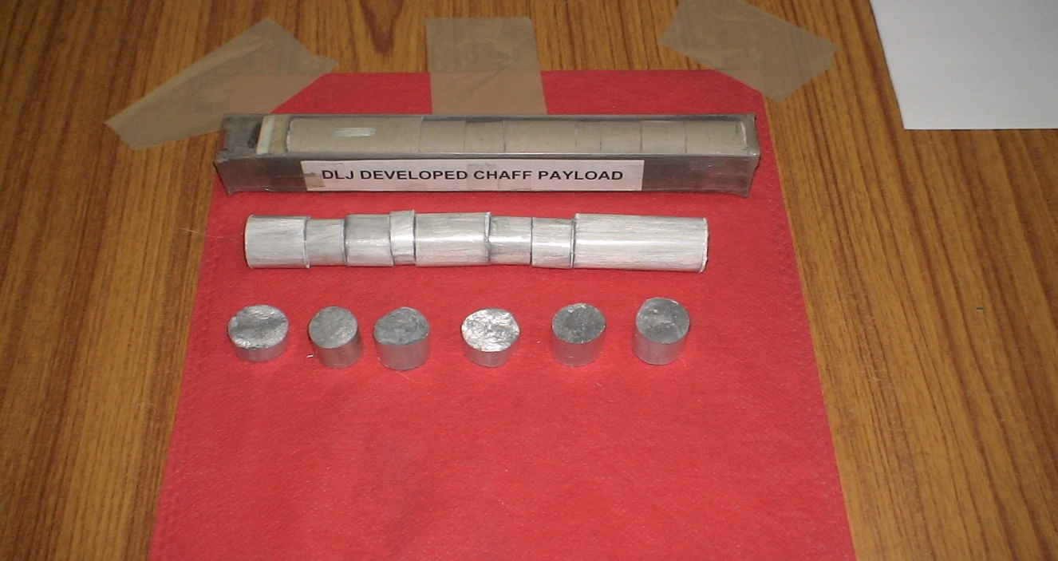
Fig. 7: Chaff Cuts of Different Lengths

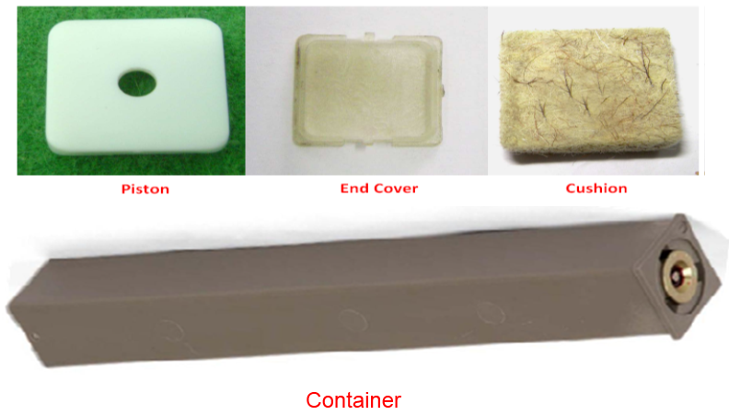
Fig. 8: External hardware for Chaff Cartridge

